**Blast and Dash Game Proposal**

**Rye George**

**CS201 Assessment 1**

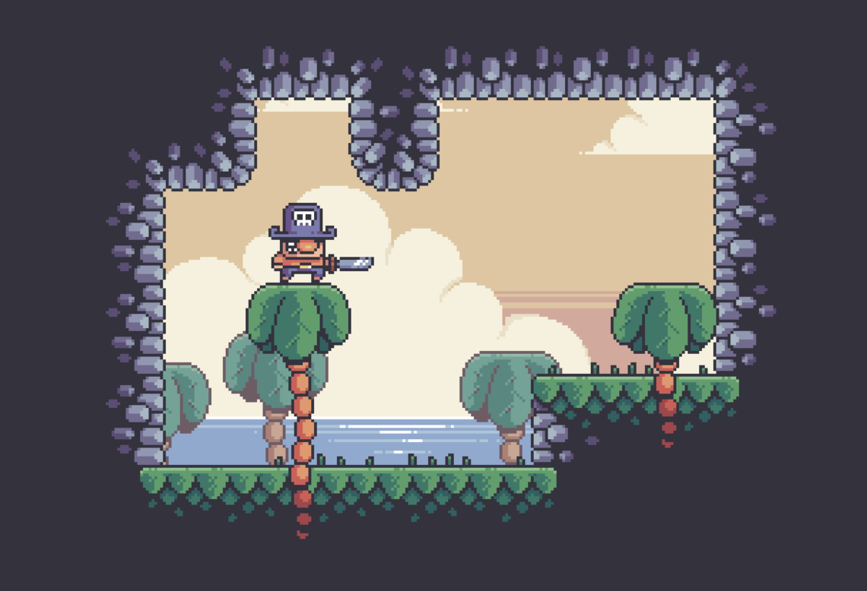

# **Executive Summary**

This document will go over the concept and game design of the proposed game “Blast and Dash”.

The games concept will be provided and all of the game features will be explained in detail.

The games target audience and unique selling points will be discussed, and finally the document will cover the constraints on this project.

# **Mission Statement**

Our goal is to develop and create a fun, engaging game that will deliver a combination of fast paced platforming and high intensity combat.

# **High Concept**

Blast and Dash is a fast-paced 2D platformer where the player can use a number of movement abilities to traverse through the games levels and increase their speed. When the player is able to correctly chain movement abilities together, gaining a high momentum they will feel powerful and unstoppable.

This creates a difficulty curve for the player, as they will be encouraged to learn how to use their various movement abilities in order to move around the game in a more satisfying way.

# **Unique Selling Points**

The game contains a couple of core features that the game is based around.

* The player can increase their momentum by chaining movement abilities together.
* The players primary weapon acts as a weapon and a movement ability.

All of the game’s features will try and contribute to these core features.

The games target audience is also based on these core features, other games with similar core features have been studied in order to attract our target audience to this game.

# **Project Parameters**

* Constraints
  + The project will be constrained by various factors. These include but are not limited to, the project duration, the project budget, and the number of team members working on the project. These factors will be discussed later in this section of the document.
* Project duration
  + The project will start on 26/03/23 and will be finished by 23/04/23, lasting four weeks.
* Alpha due
  + The due date for the project is 23/04/23.
* Engine
  + The game will be developed using the Unity game engine. Unity provided a variety of features that make the development of 2D platformers much easier. This will help us develop the game within the provided time frame.
* Target platforms
  + The target platform for our game is the PC. Platformer games are most popular on PC, and this is where our target audience is.
* Target hardware
  + The game will be optimized to ensure that it can run on any PC. The player will be able to run the game on almost any hardware.
* Primary programming language
  + The game will be developed using C#. C# is the primary programming language used within Unity.
* Team size
  + The game will be developed by a single developer. This developer will be responsible for the games programming, design, and art.
* Project methodology
  + The project will use an agile development methodology.
* Budget
  + The budget for the project is $6000. 30 hours of development a week, for 120 hours, with a developer salary of $50.00 per hour.
* Software and tools
  + The project will use various software and tools throughout the project. Below is a list of these software and tools:
    - Unity Game Engine
    - Visual Studio
    - Git / GitHub
* Target audience
  + Our target audience is based on the audience of other similar games in our genre. Some of these games are Super Meat Bot, Celeste, and Ori and The Blind Forest. Some aspects of these games that our target audience enjoy are:
    - Satisfying movement.
    - Responsive controls.
    - Clear art design

The game has been designed and will be developed based on what our target audience enjoy.

# **Gameplay Overview** The game will include a variety of gameplay features that will contribute to the core idea of the game.

These features are:

* Wall jumping.
  + The player will be able to jump off of walls, giving them an extra boost in momentum and allowing them to reach higher places.
* Wall sliding.
  + While the player is against a wall they will slide down it. This features pairs well with wall jumping as the player will be able to slide down a wall and then wall jump once they have reached the desired position.
* Dashing
  + By pressing the left shift button the player will gain a boost of momentum and be pushed forward. This feature will help the player traverse the games level easier, for example the player will be able to jump gaps by dashing that would be too far by only jumping.
* Shotgun
  + The player will have a shotgun. This shotgun will have two uses, as a weapon, and for movement. By shooting the shotgun the player will launched in the opposite direction of the shotgun. This helps make sure that the games combat works with the games core idea of movement and momentum. The shotgun will also be the primary weapon in the game.

All of these features contribute to the games core concept of movement-based gameplay. Every gameplay mechanic will be used in some way to keep the player moving as much as possible.

Even the players weapon contributes to this concept, as it can be used as a movement tool and will give the player a momentum boost.

# **User Interface**

The layout of the games UI will use only what is necessary and try to keep the design as minimalist as possible.

The focus of the game should be on the player, and the gameplay. The UI should be a way to provide information to the player. Overloading the player with information can lead to a bad game experience and confusing gameplay.

By default, the only UI element visible to the player will be their healthbar, as this is the only information needed by the player at the time.

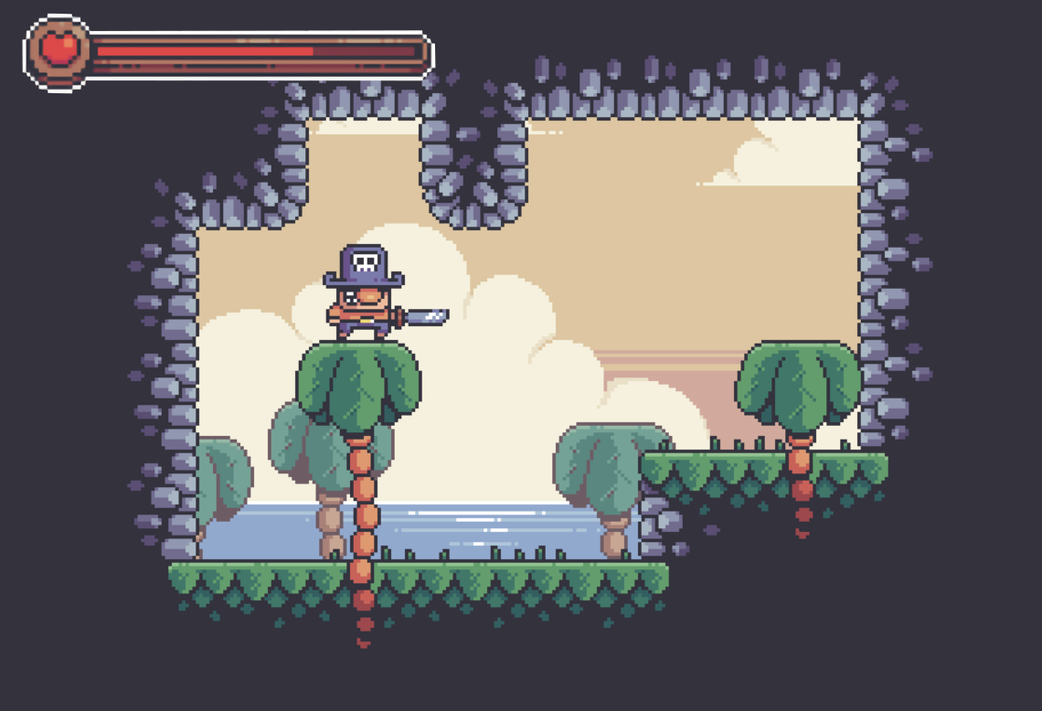

Enemies will have a health bar that displays once they are hit. Before the player hits the enemy no health bar will be displayed.

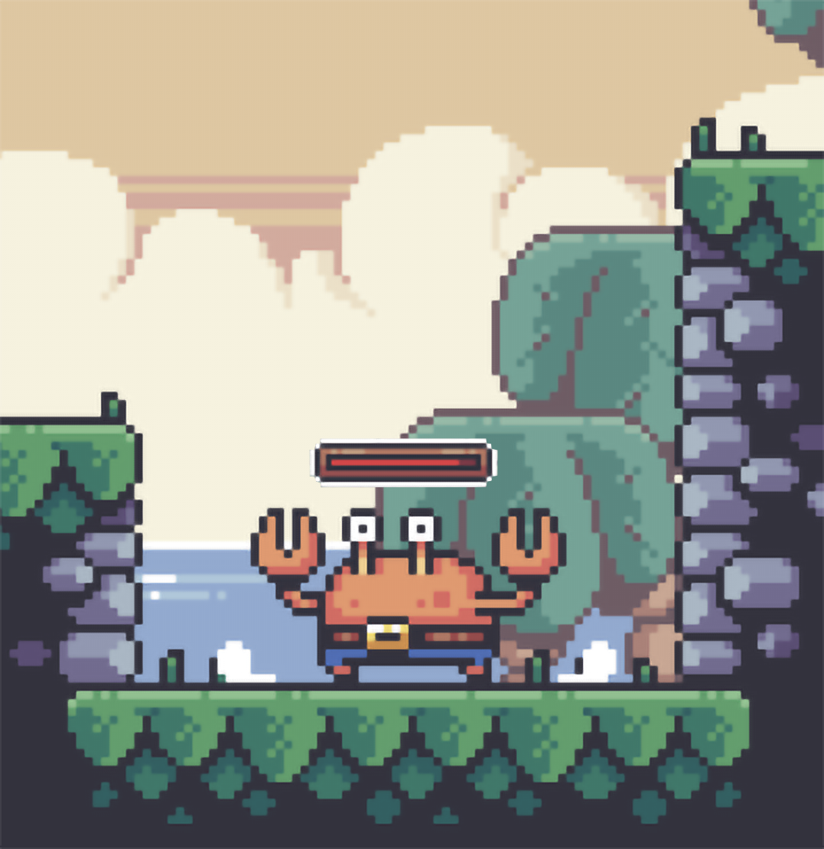

These UI elements are the only elements visisble to the player during regular gameplay.